You have been tasked with creating a simple calculator which has the basic functions to add, subtract, multiply, and divide two numbers.

The layout of the calculator should look as below, but all other styles are your choice.

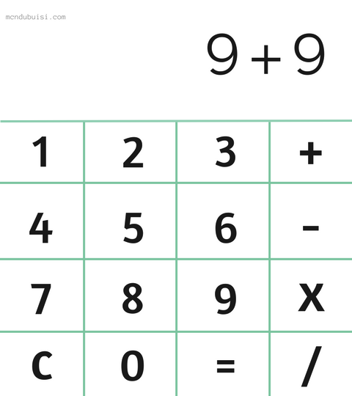

The display of the calculator must show the calculation before equal is pressed to show the answer.

If C is clicked, it should return the display back to 0

**STRETCH** {

Add a full stop which can be used to add numbers with decimal points.

Add other functions which allow the user to do calculations like

* Squared
* Cubed
* Power of user’s choice
* Modulus
* Convert Denary to Binary
* Convert Binary to Denary

}